Import Procedure: Business Line and Responsabilità
The request is to create a new Import Procedure = number 10:
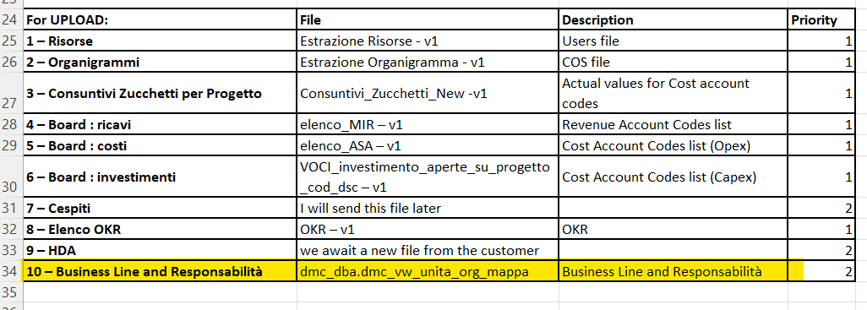

The template (file excel) is attached in the ticket.
The procedure will have to import the following columns of the attached file:
- Code “ID Soggetto” = A column
- Description “ID Soggetto” = B column
- Code “Mappa direzionale di III Livello” = G column
- Description “Mappa direzionale di III Livello” = H column
- Code “Mappa direzionale di II Livello” = I column
- Description “Mappa direzionale di II Livello” = J column
- Code “Business Line” = M column
- Description “Business Line” = N column

After importing these values, the procedure will have to insert the values in the COS attributes: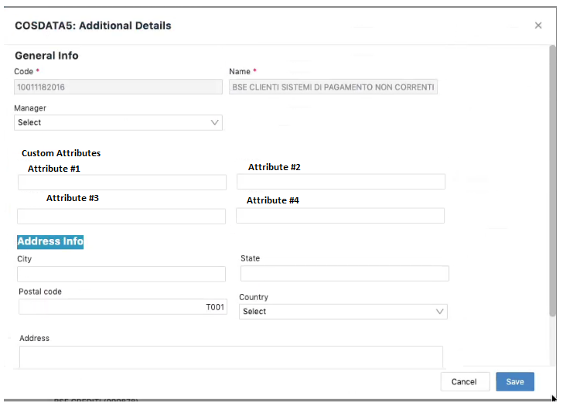
Attribute #1 = Description Mappa direzionale di III Livello = In the excel file is H column
Attribute #2 = Description Mappa direzionale di II Livello = In the excel file is J column
Attribute #3 = Description Business Line = In the excel file is N column

In the file we have the IDs Soggetto (A column), these ids correspond to COS level 5 node ids.
For each ID soggetto (lev 5) the procedure must add Attribute 1,2 and 3 based on the file.
For example:
In the ID Soggetto 900002360 the procedure must insert the following Attributes:
Attribute #1 = GBS Innovation
Attribute #2 = GBS Trasformation
Attribute #3 = One Sella Corporate Center

